CST2355 – Database Systems Lab Assignment 6

Student Name: Nouraldin Hassan

Student ID: 041054019

Student email: hass0443@algonoquinlive.com

# Hand-in:

1. The lab assignment will be graded out of a maximum 4 points.
2. This template should be used to submit your lab assignment.
3. Make sure you have enough screenshots to completely document that you have completed all the steps.

# Activities (Steps):

1. In this lab you will be using the PostgreSQL (Version 15.1 or later) database management system, and pgAdmin4 (the current database administration application for PostgreSQL). The first step is to get the software installed.
   1. Navigate to: <https://www.postgresql.org/download/windows/>

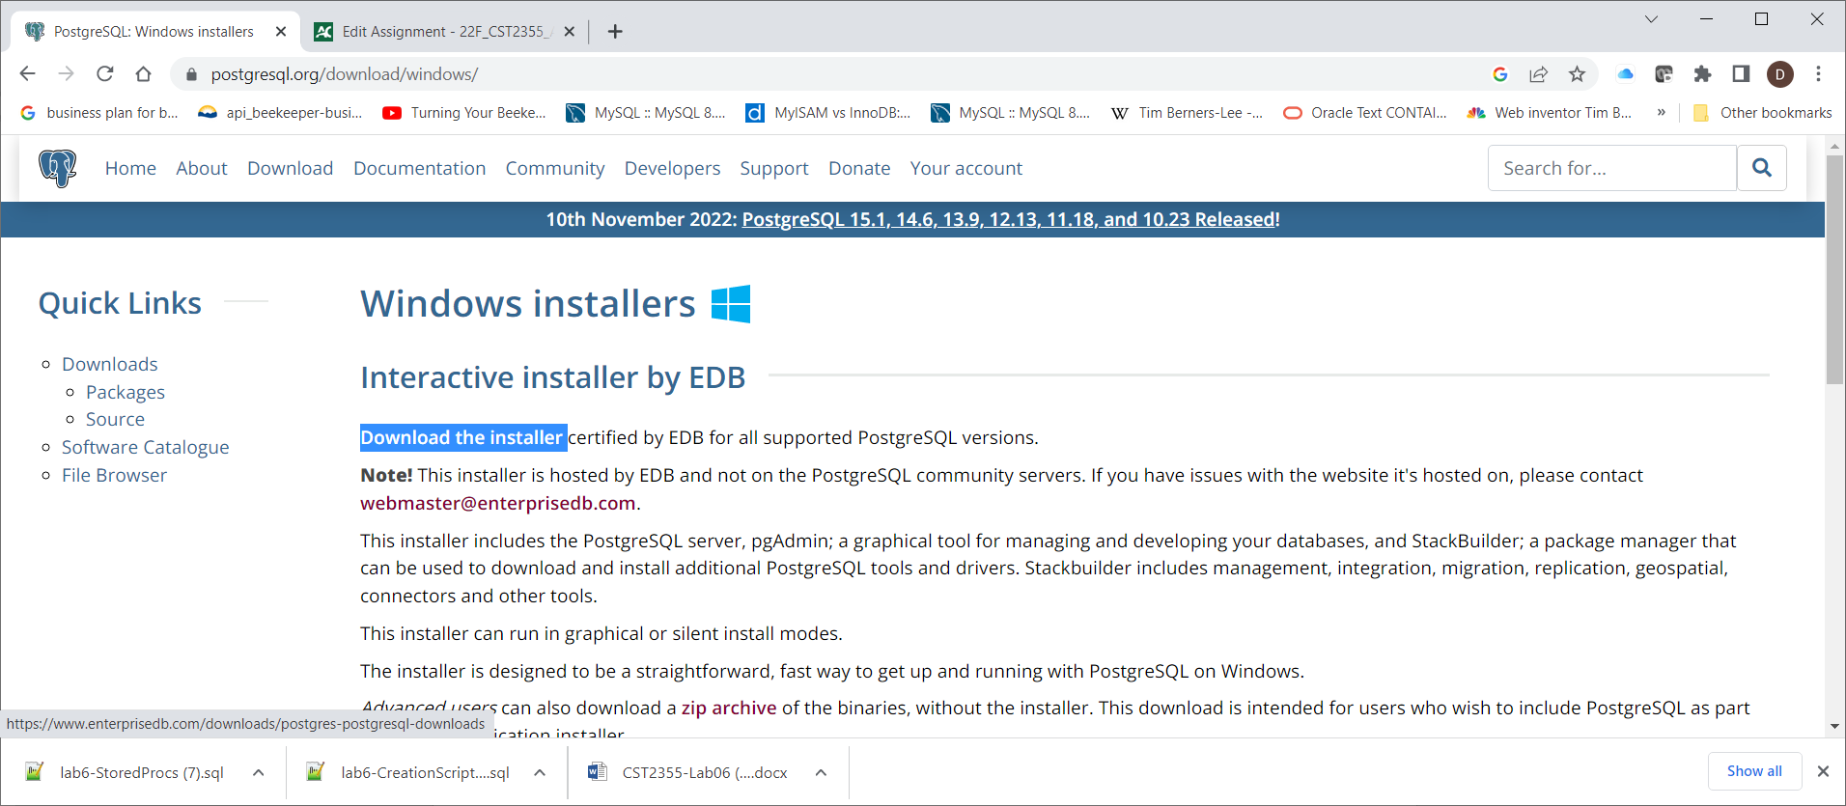

* 1. Click on the “Download the installer” link and then select the Version 15.1 version (321MB)
  2. Once the download is complete, execute the downloaded .EXE file to begin the installation:

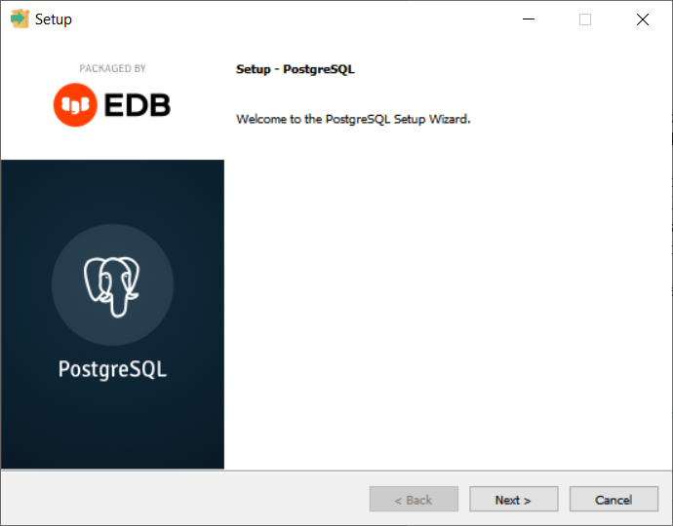

* 1. Work through the installation steps as outlined below:
     1. When you get to the screen asking for which products you would like to install, select them all:

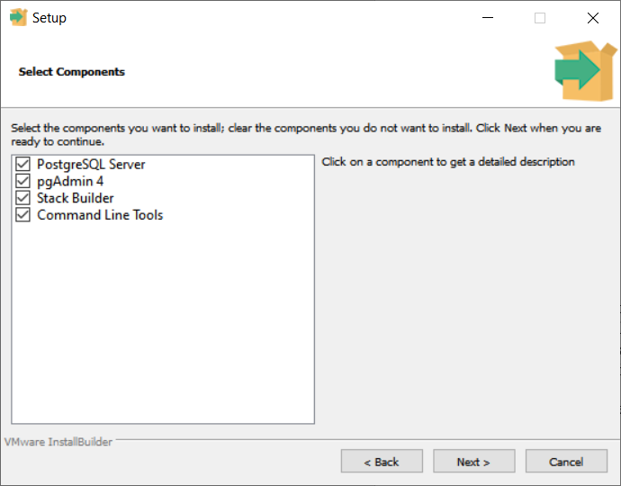

* + 1. When you get to the screen asking for the password, make sure you choose something easy to remember ( e.g. something like *yourlastname*123 )

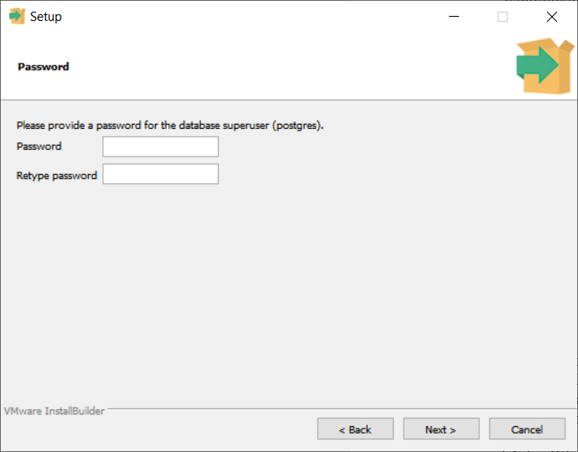

* + 1. When you get to the screen asking for the port number, leave it as the default ( i.e., 5432 – my default is 5433 below because there was already an older version running on port 5432). This sets the TCP/IP port on which the new database server will be listening.

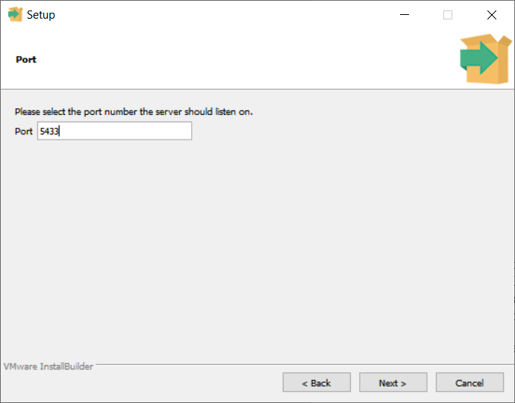

* 1. When the installation is complete (it will take some time – perhaps 10 min), you will be prompted with a confirmation screen. **Take a screenshot of the confirmation screen and paste it below.**
     1. Here is mine:

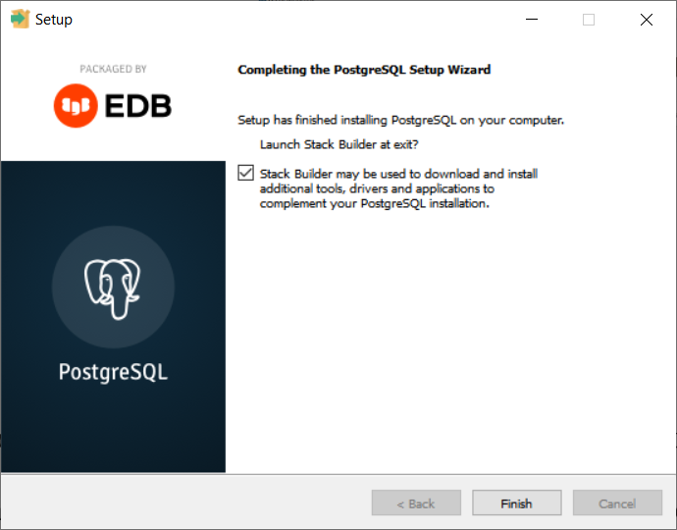

* + 1. **Yours goes here: (PROVIDE A SCREENSHOT!)**

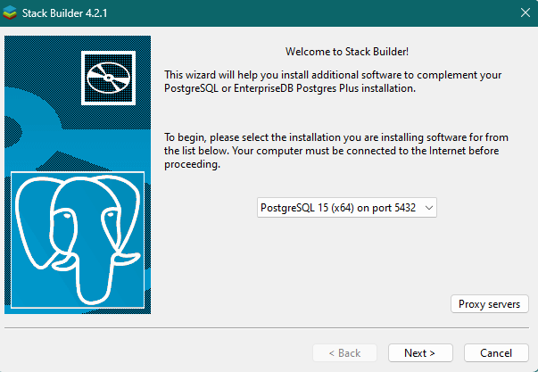 **Note:** I forgot to take a screenshot of the finishing wizard, so here is the tab for stack builder which opened from the wizard.

* 1. Make sure the option IS selected for “Launch Stack Builder at exit” option and then click on Finish.
  2. Stack Builder will run (it will install any adapters you might use in the future to build applications using PostgreSQL as the database):
     1. When prompted, select the PostgreSQL 15 server running on port 5432, so that all the future tools will be pointed at that installation by default.

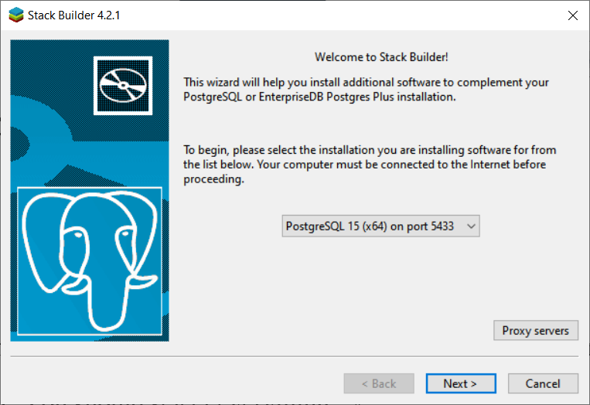

* + 1. Then select the Postgres ODBC drivers (and JDBC driver if you think you might use it later – not in this course) as shown below:

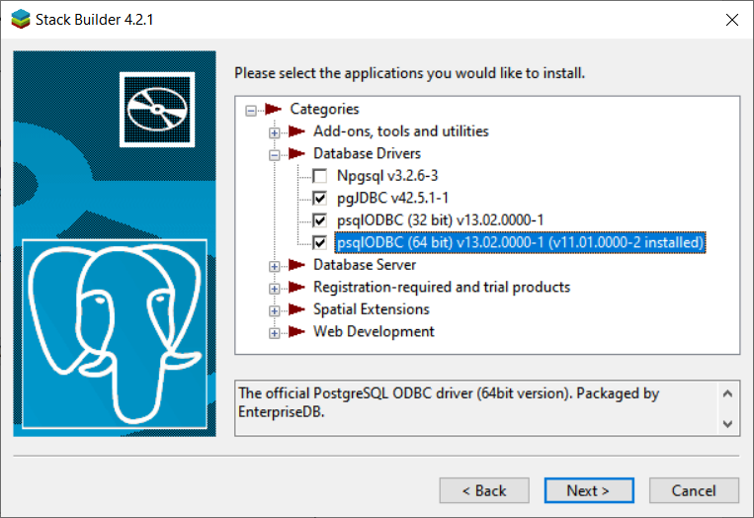

* + 1. Click Next and complete the installation for each of the selected client drivers. (ODBC and possibly ODBC). (There will be several pop-up installation screens).
    2. Installation should now be complete! You have the Postgres server and pgAdmin (the workbench administration tool for Postgres) ready to go.

1. Open “pgAdmin4” from the Windows Start Menu. You should see something like this:

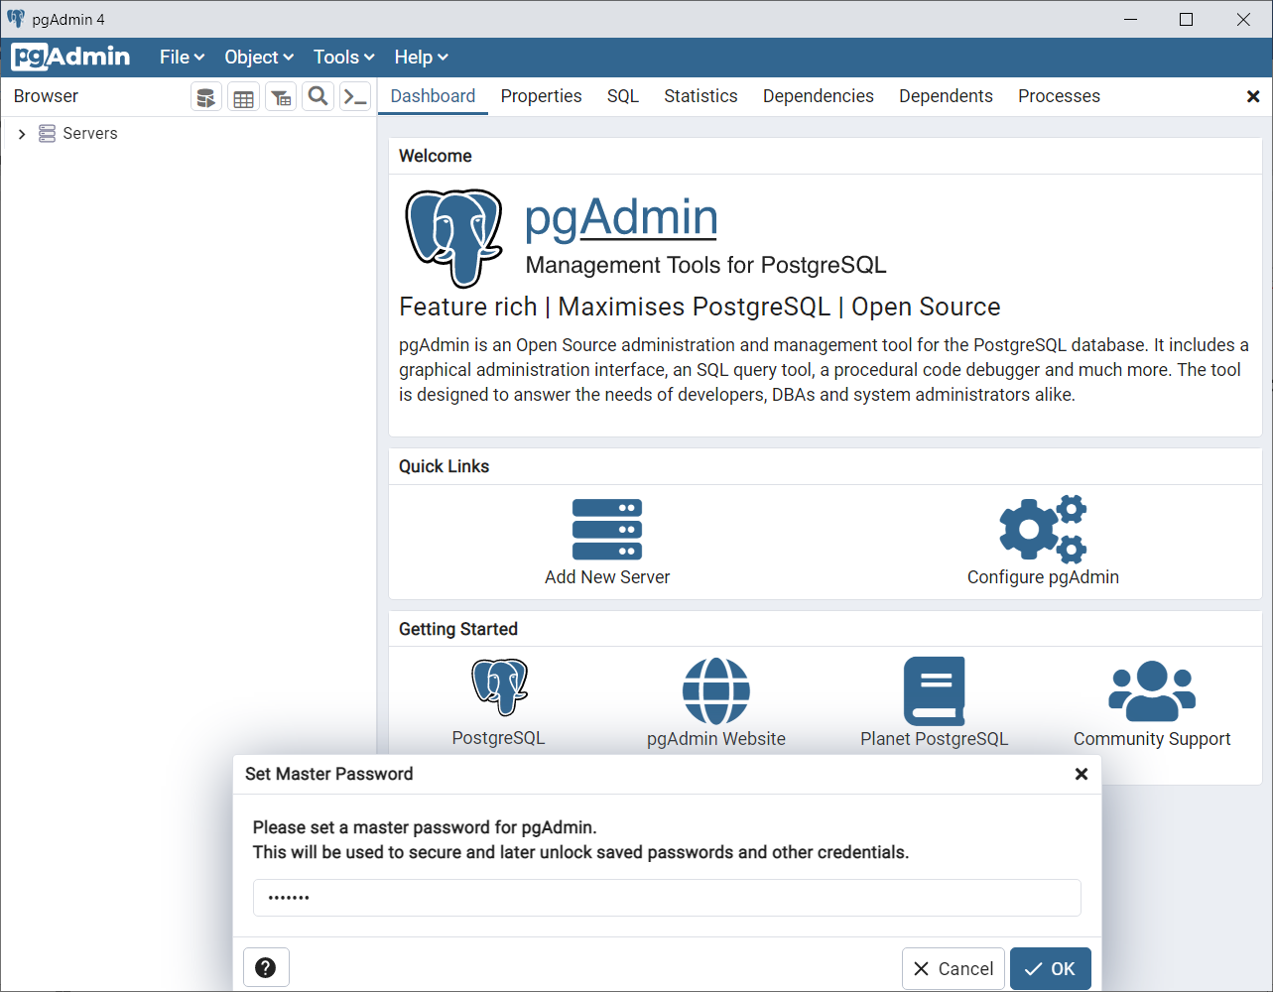

* 1. Enter a master password for pgAdmin (e.g., *yourlastname1234)* and click OK. This sets the password for running pgAdmin4 on your client laptop.
  2. If you click on the “Servers” link on the left hand navigator pane, then you will see a list of servers to which you could connect. (You will likely only have one available.):
     1. Select the “PostgreSQL 15” server and then use the “Object > Connect Server” menu item to create a connection to that server. You will be prompted for your database server admin password (e.g., *yourlastname*123)

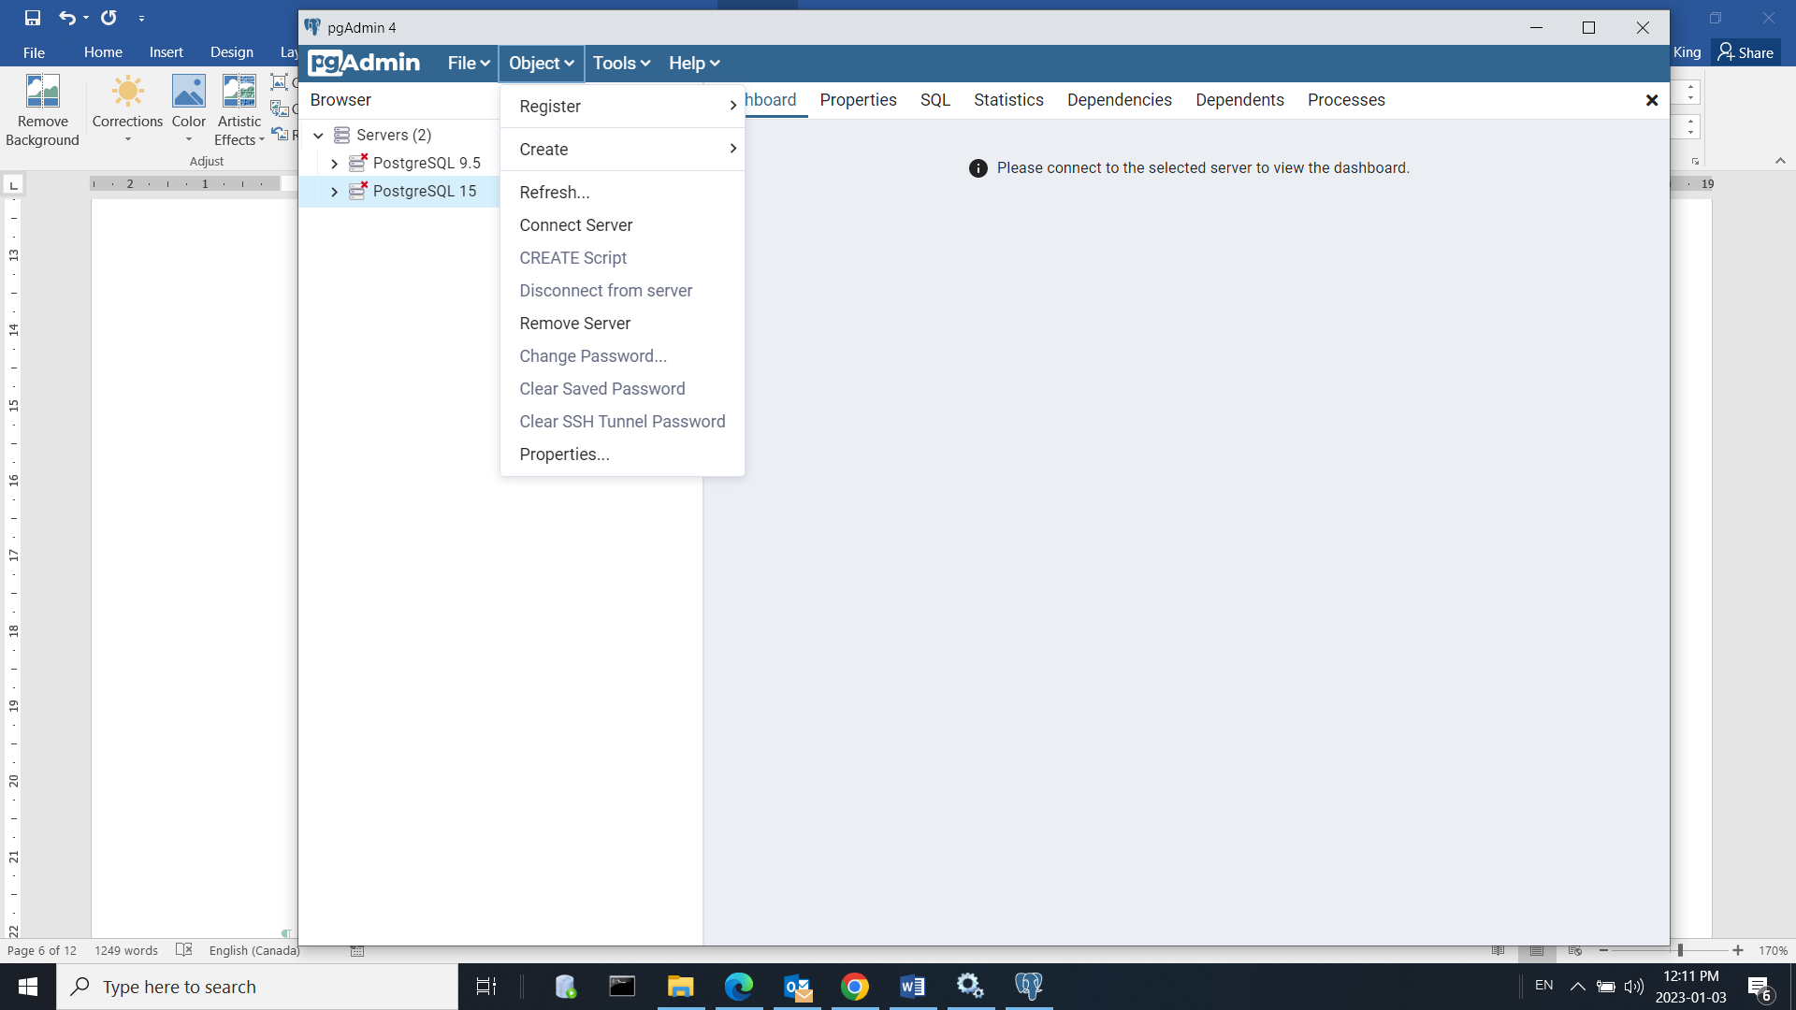

* + 1. Once connected, you will see a dashboard showing the current status of your server:

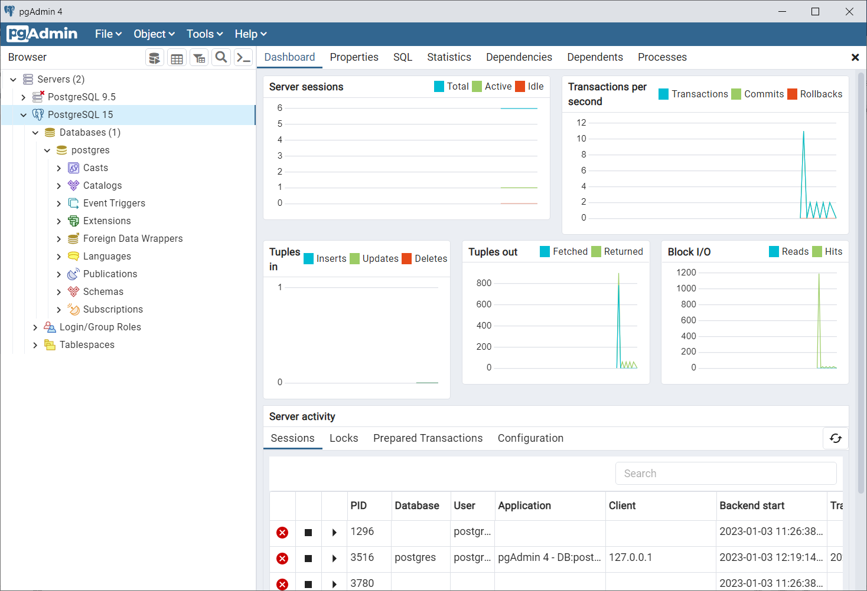

* + 1. Provide a screenshot below showing your dashboard:

* + 1. Now we will create a personal connection to connect to the PostgreSQL 15 server without administrative privileges.
       1. Click on the “PostgreSQL 15” server.
       2. Select the Login/Group Roles item under the PostgreSQL navigation menu. Then do a right-mouse-click to get the pop-up menu (see below), and select login/group role.

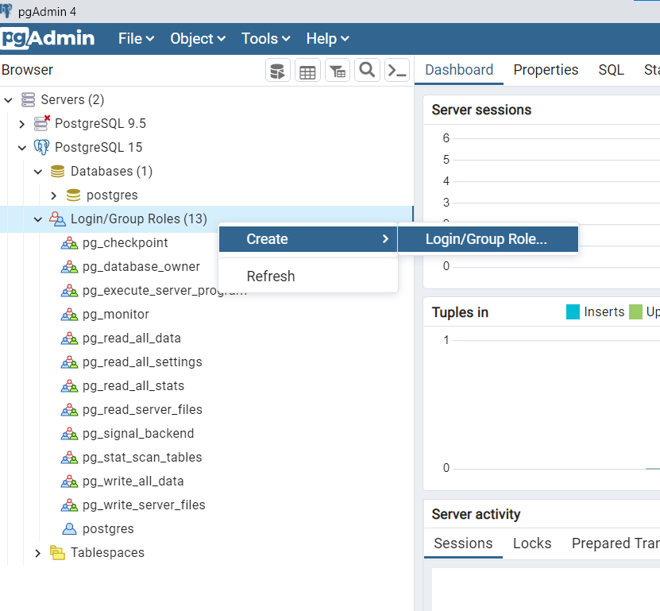

* + - 1. You will get prompted for the login/role name. Use something like “*yourlastname*User” where *yourlastname* is your family name. See below for my example.

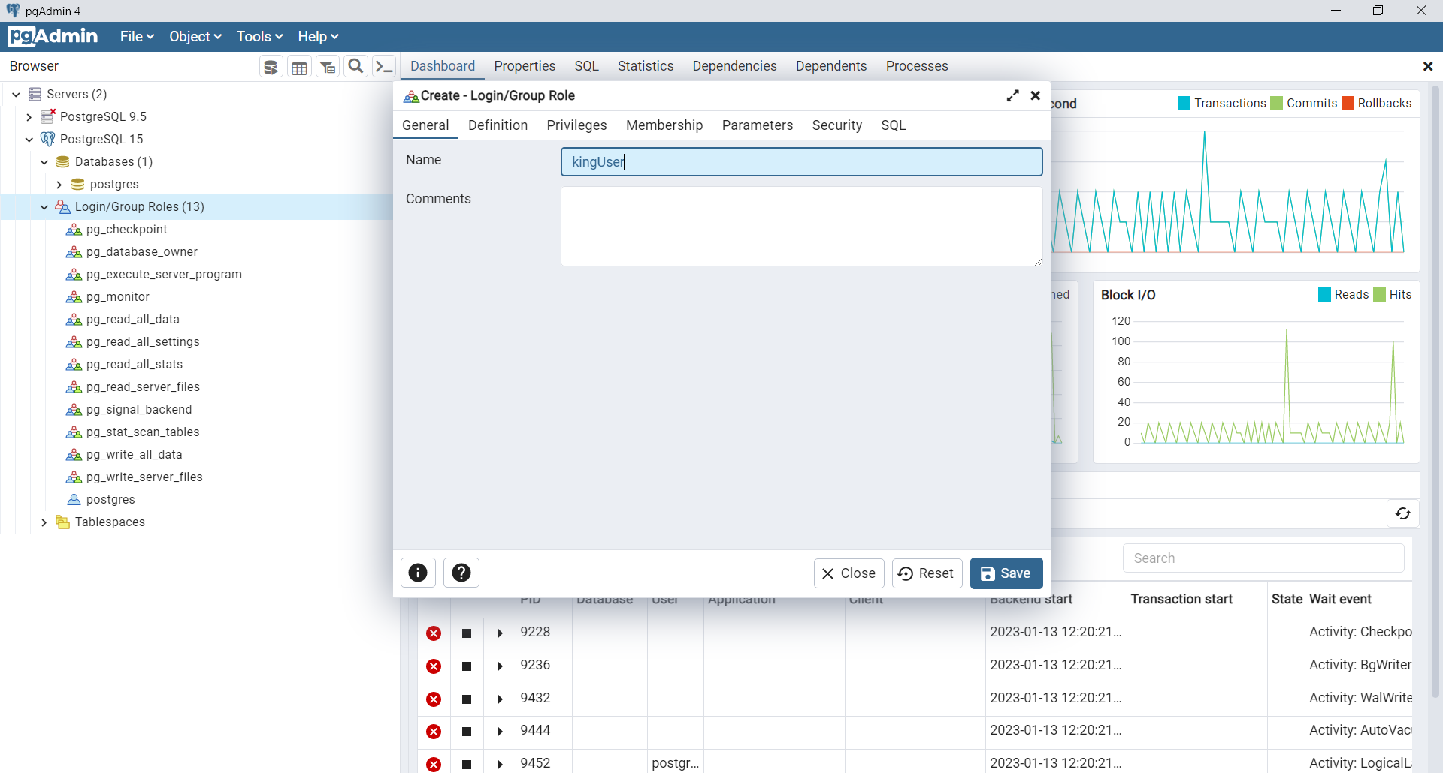

* + - 1. Before creating the role, move to the “Definition” tab and set the password to something like “*yourlastname12”.*

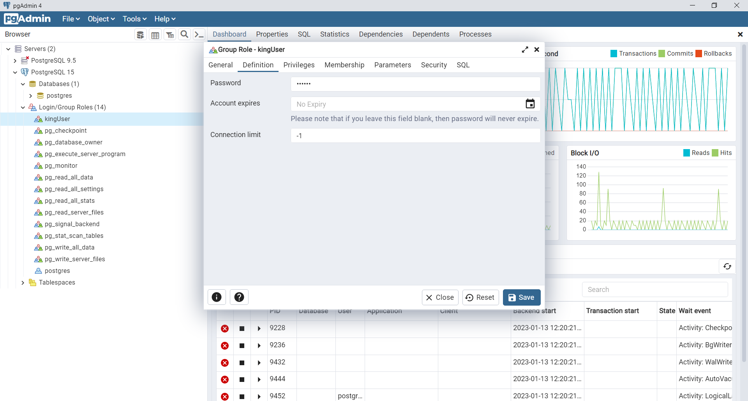

* + - 1. Then move to the “Privileges” tab and allow logins (see below).

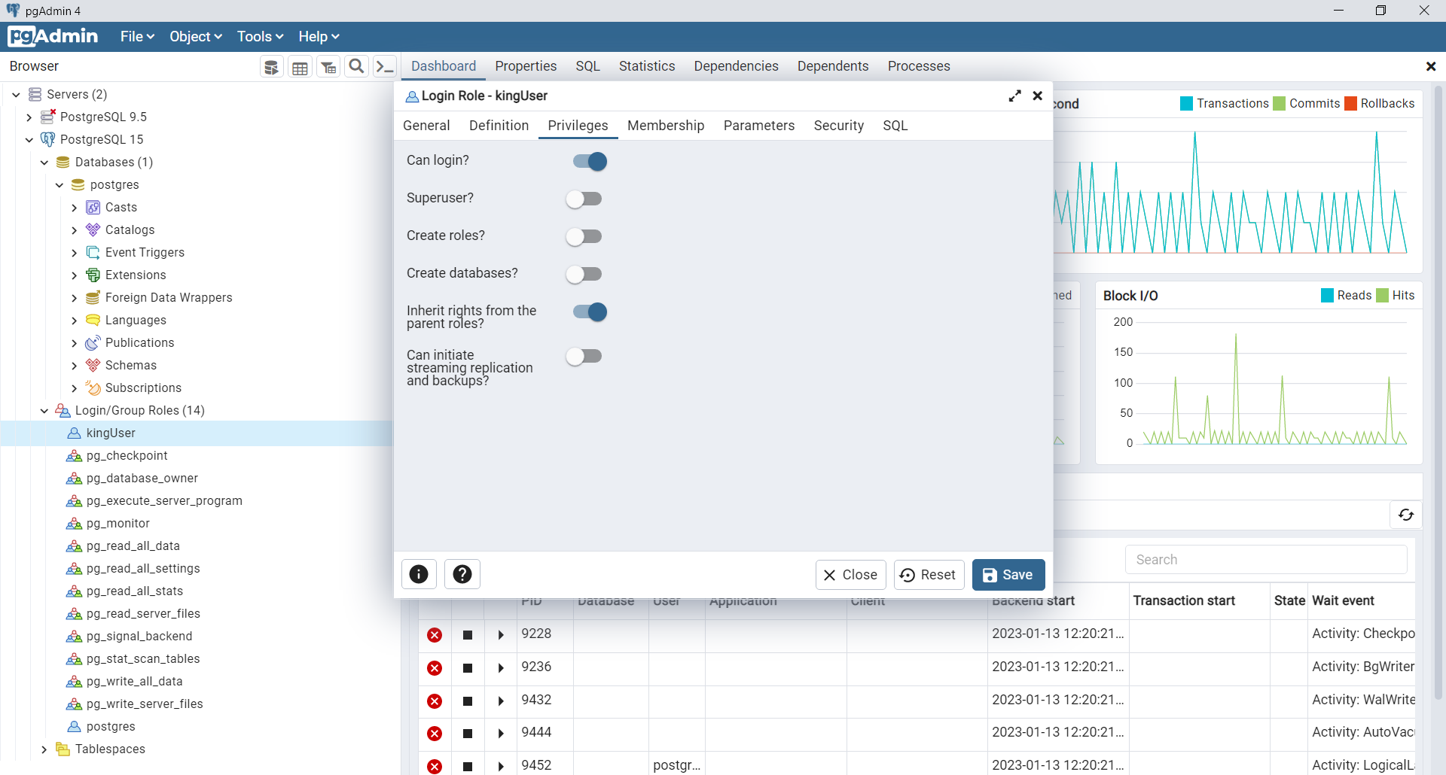

* + - 1. Then click the Save button and the login/role should now be available.
  1. Now we will create a new tablespace to use for the future database that “*yourlastname*User” will use to create tables in this lab.
     1. First, create an empty folder where the postgres data will be stored. I created mine in “D:\postgres-data\lab6-kingUser-location”. You ***need*** to use a similar location name that includes lab6 and your login/role name so that you can make a nice screenshot later at the very end of this lab! We use this location when creating the tablespace for the database.
     2. Navigate to the “Tablespaces” item under PostgreSQL 15 server and select the “Create > Tablespace” item from the right-mouse-click pop-up menu (see below

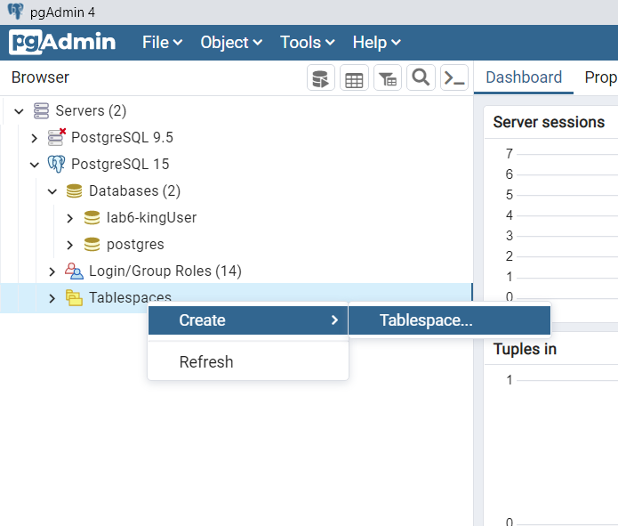

* 1. Now we will create an empty database that the “*yourlastname*User” will use to create tables in this lab.
     1. You need to set the tablespace name and owner in the “General” tab:

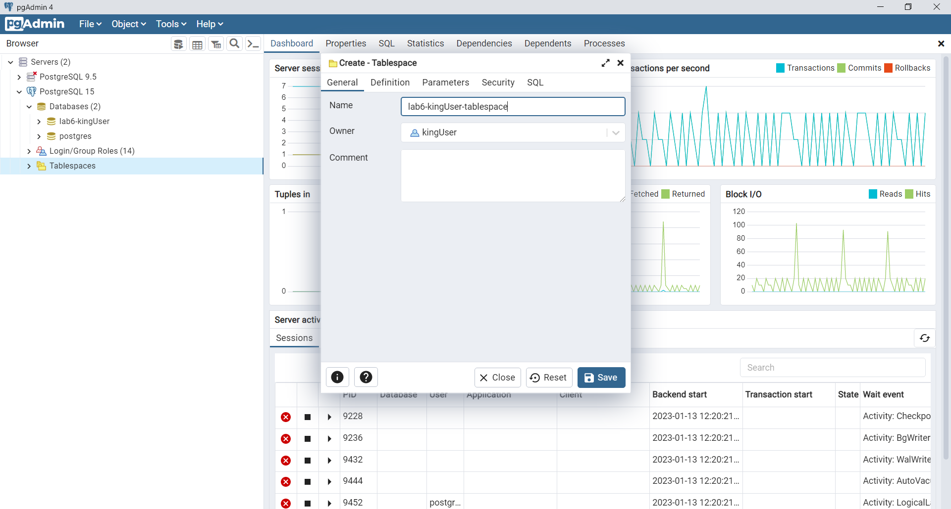

* + 1. And navigate to the “Definition” tab to set the location

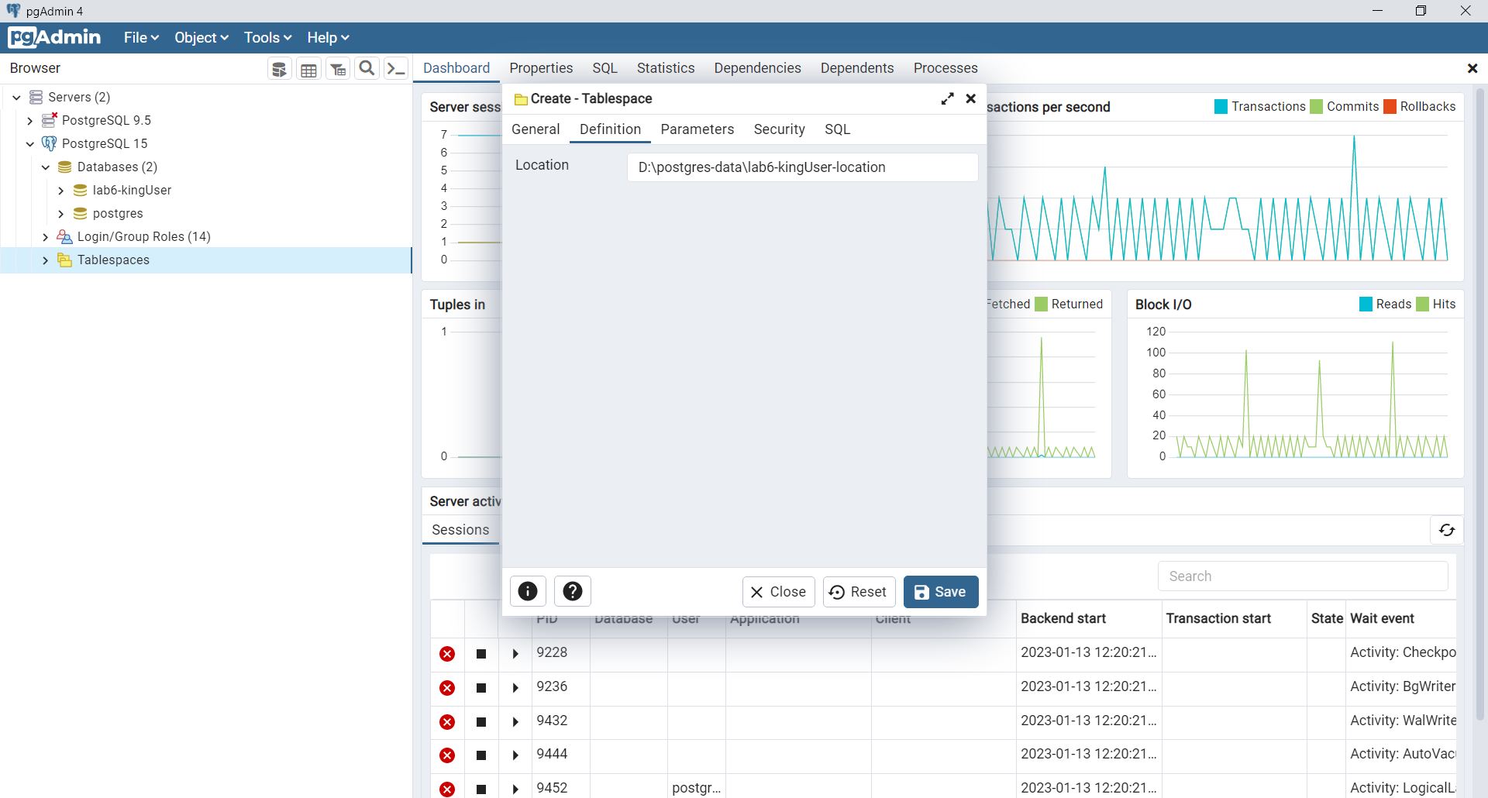

* + 1. Click the Save button and the tablespace will be ready to use. Having this tablespace would simplify the backup/restore and general management of the lab6-kingUser database we are about to create.

1. Now for the creation of the database.
   1. Select the “Databases” item under PostgreSQL 15 and right-mouse click to see the pop-up menu. Select the “Create > Database” option. (see below)

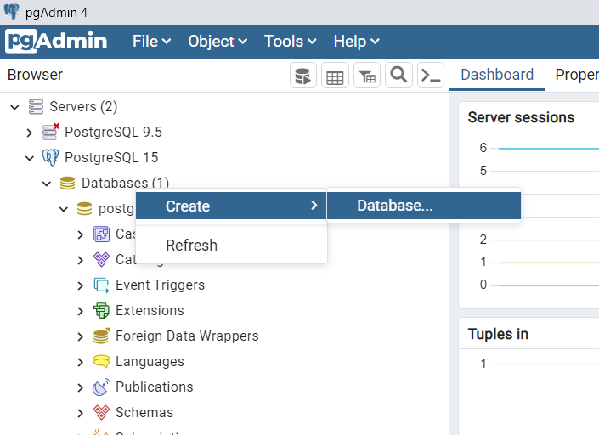

* + 1. Then on the “General” tab give the database a name based on your new login, and make sure you set the “owner” to your new login/role (see below).

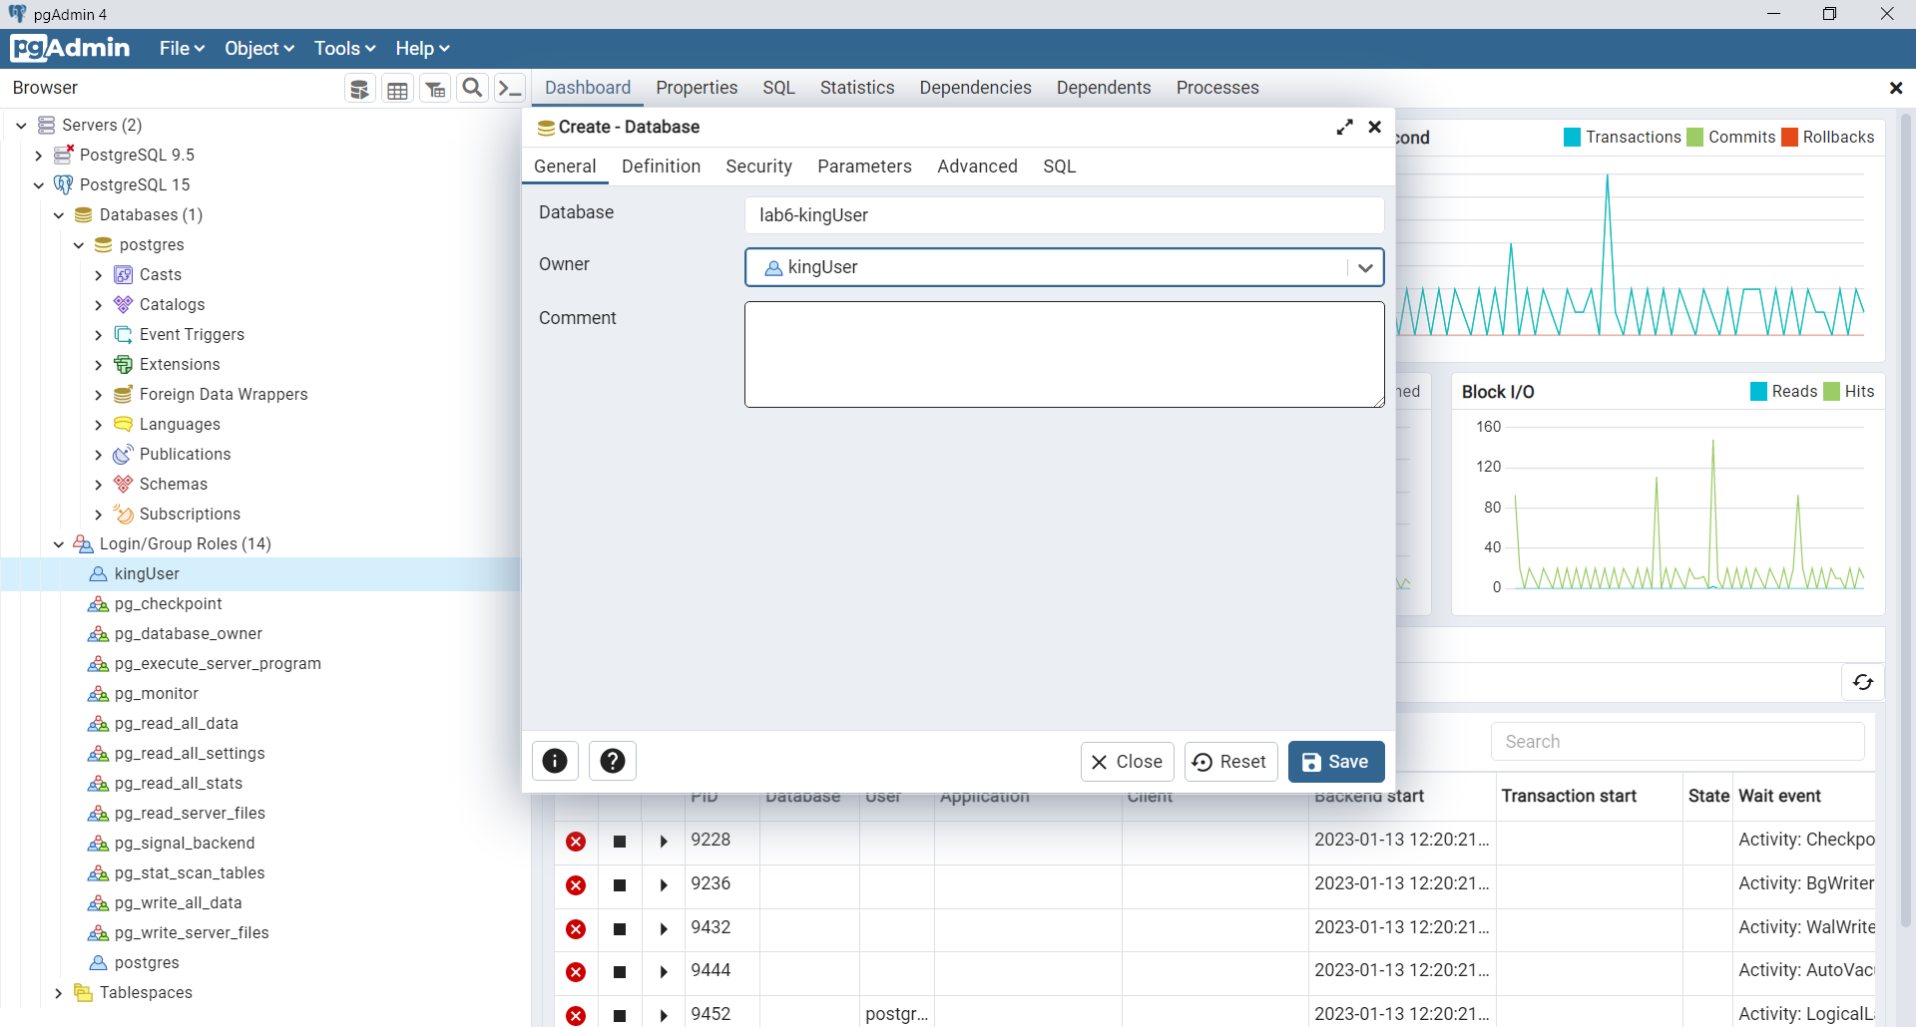

* + 1. Navigate to the “Definition” tab to set the location (the tablespace)

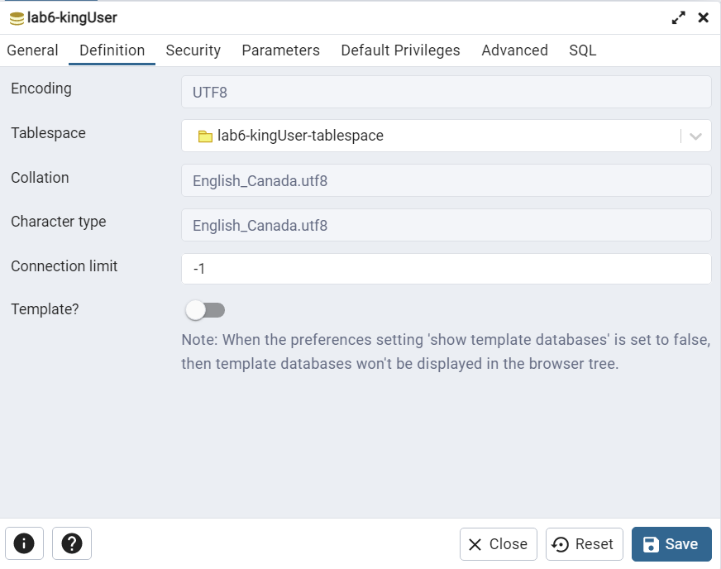

* 1. Then click Save and the database should now be listed under PostgreSQL 15 Server in the navigation menu. Provide a screenshot showing your database and tablespace available in the navigation menu. Here’s mine (see below)

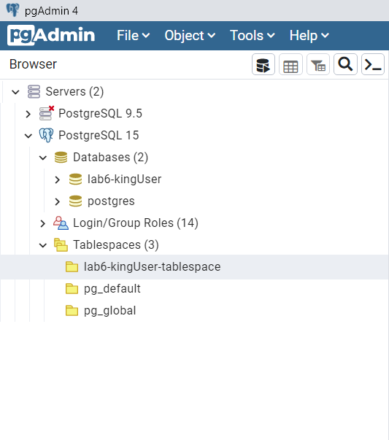

* 1. Paste yours below:

* 1. Everything is now ready to connect and create the tables for this lab!

1. Go back to the Main navigation menu on the left side and select Servers. Then right-mouse click to see the pop-up menu and select the “Register > Server” option (see below):

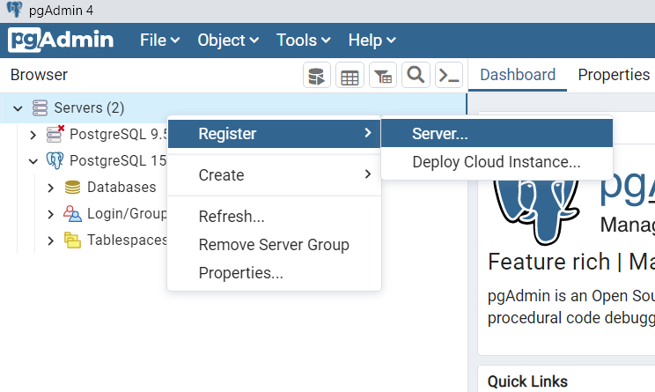

* 1. Select the General tab, set the server name – (actually a separately defined connection to the server..)

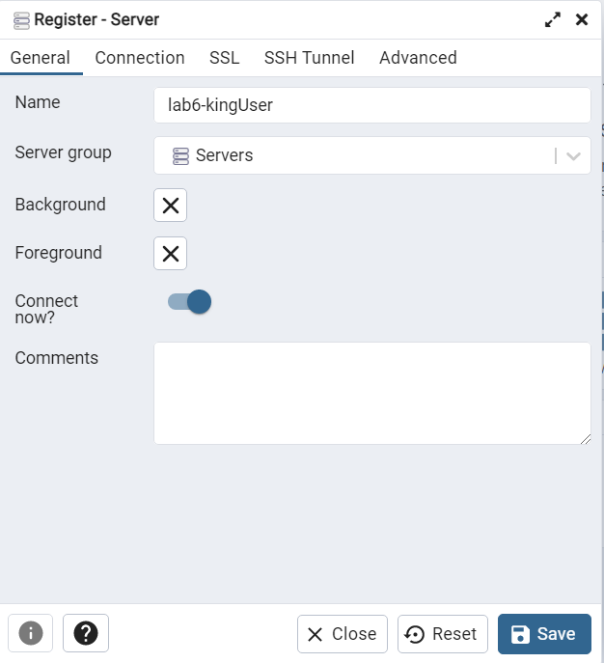

* 1. On the “Definition” tab, set the connection parameters:

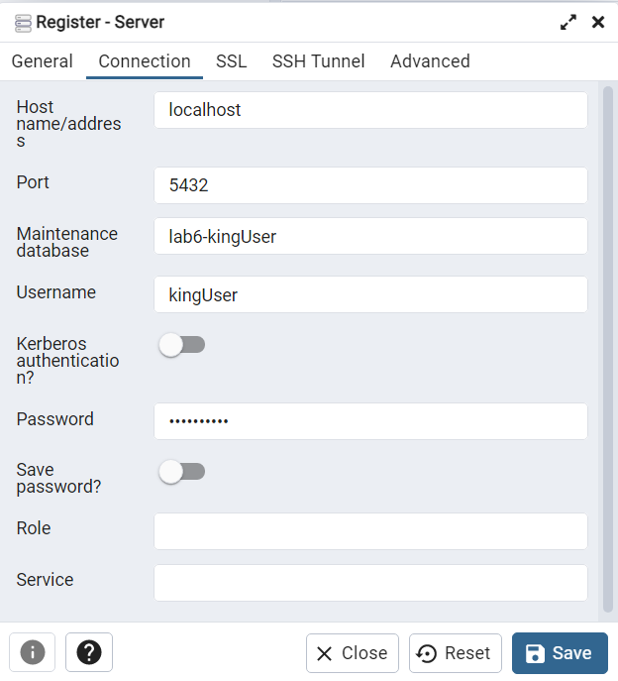

* 1. Provide a screenshot similar to that below to show your created database ready and connected. Here’s mine

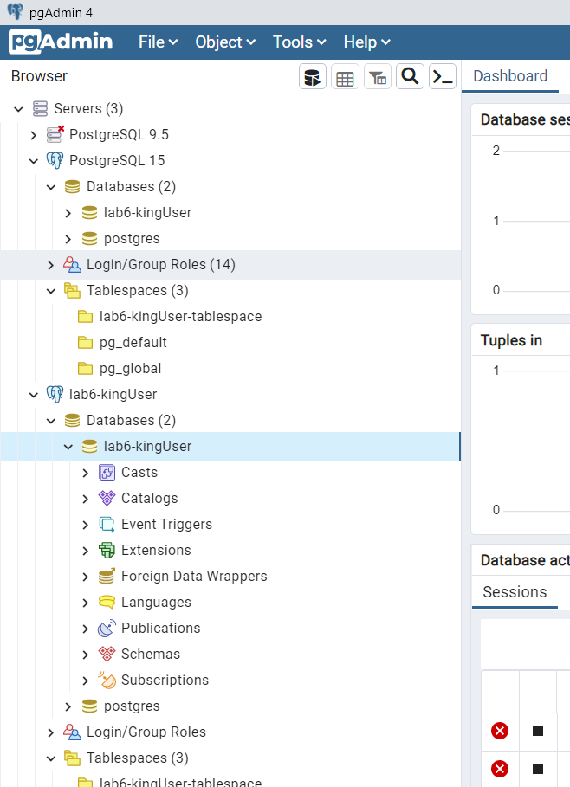

* 1. Paste your screenshot below:

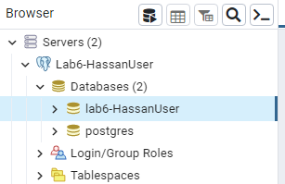

1. Now, we will use the new connection to create an interesting database and create a trigger!
   1. Select your new database under the new connection and then open the query tool as shown below:

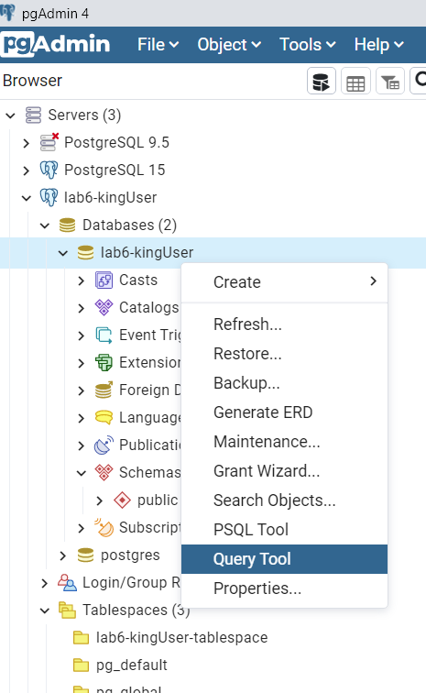

* 1. Once the query tool is open, paste the contents of the “lab6-creationPG.sql” file (supplied in Brightspace) into the query window and execute the script.
     1. Provide a screenshot showing the list of created tables inside your database.

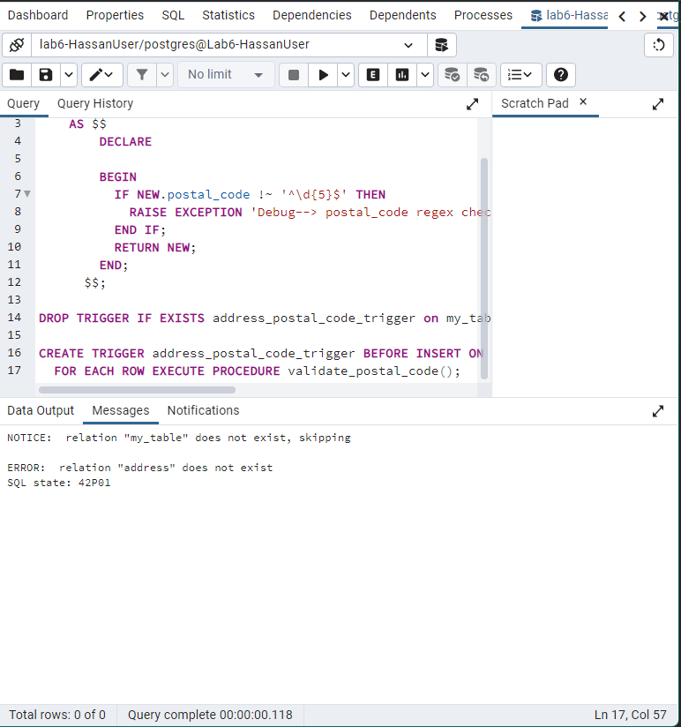  
**Note:** I could not find where the tables are exactly

* + 1. Provide a screenshot showing the output of the query “select * from address;”

**Note:** using address_postal_code_trigger or $$ did not work.

1. We now are going to build some triggers.
   1. To get ready, use the menus in the navigator window to change the field size of the postalcode fields in the “address” and “retaillocation” tables to each be of 6 characters in length.
   2. Use the supplied “lab6-triggerPG.sql” script to create a trigger (using the query window) on the “address” table to be activated “before insert” on the table. It checks the postal code field is formatted as “A1B2C3”. If the format is not correct, the trigger will rollback the entire transaction and raise an exception and return a message to the calling program.
      1. The script creates a trigger function which we will use in multiple triggers, and then creates the trigger on the “address” table. That trigger calls the validation function for each row that is being inserted.
   3. Provide a screenshot showing the results after your trigger is in place for each of the following:
      1. An insert of an address with a well-formatted postal code:
      2. An insert of an address with a badly-formatted postal code:
   4. Use the menus in the navigator window to modify the properties on the address table trigger to get it to run for both inserts and updates.
      1. Provide a screenshot for a failed update attempt.
   5. Use the menus in the navigator window to CREATE a new trigger on the retaillocation table. Use the tabs to specify the reuse of the trigger function that was used in the address table trigger. Specify the trigger to run on both inserts and updates.
      1. Provide a screenshot showing the results after your trigger is in place for each of the following:
         1. An insert of a retaillocation with a well-formatted postal code:
         2. An update of a retaillocation with a badly-formatted postal code:
2. Make sure you save all your queries before you exit.
3. As the last step in the lab, navigate to the folder you specified for your tablespace, and provide a screenshot which shows the folder structure:
   1. Here is mine:

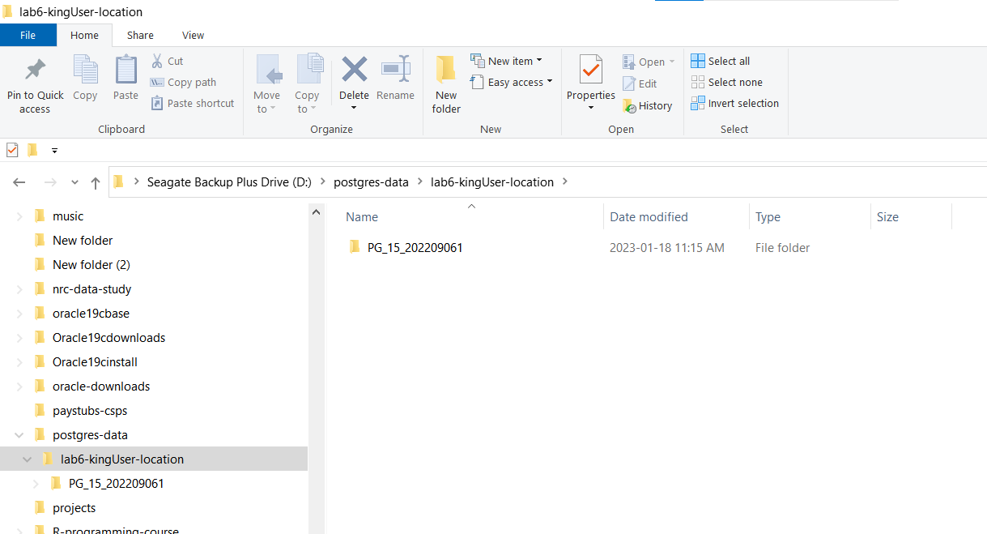

* 1. Paste yours here:

1. Once you have embedded all of your screenshots, submit the file in Brightspace and you’re done!